*Note: this report was written by Abdullah (520514492).*

**Basic functionality requirement 1.**

Vincent: Password hashed using *hashFunc()* so server cannot know contents of password.

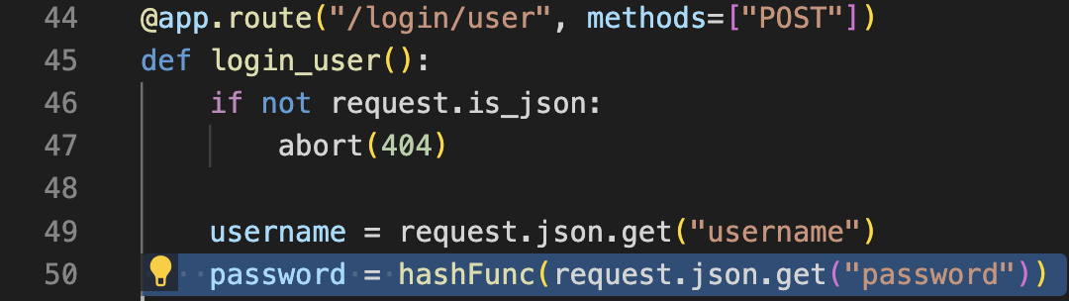

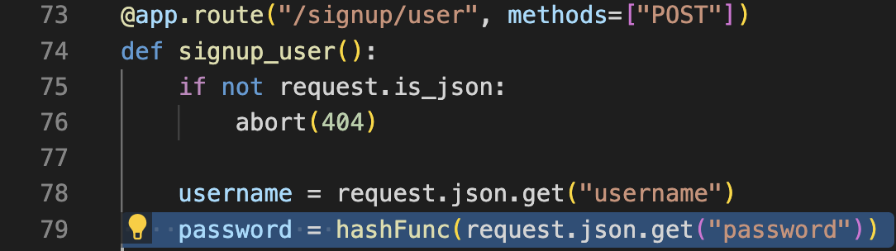

Abdullah: Setting *SESSION_COOKIE_HTTPONLY* to true ensure JavaScript cannot access the session cookie.



**Basic functionality requirement 2.**

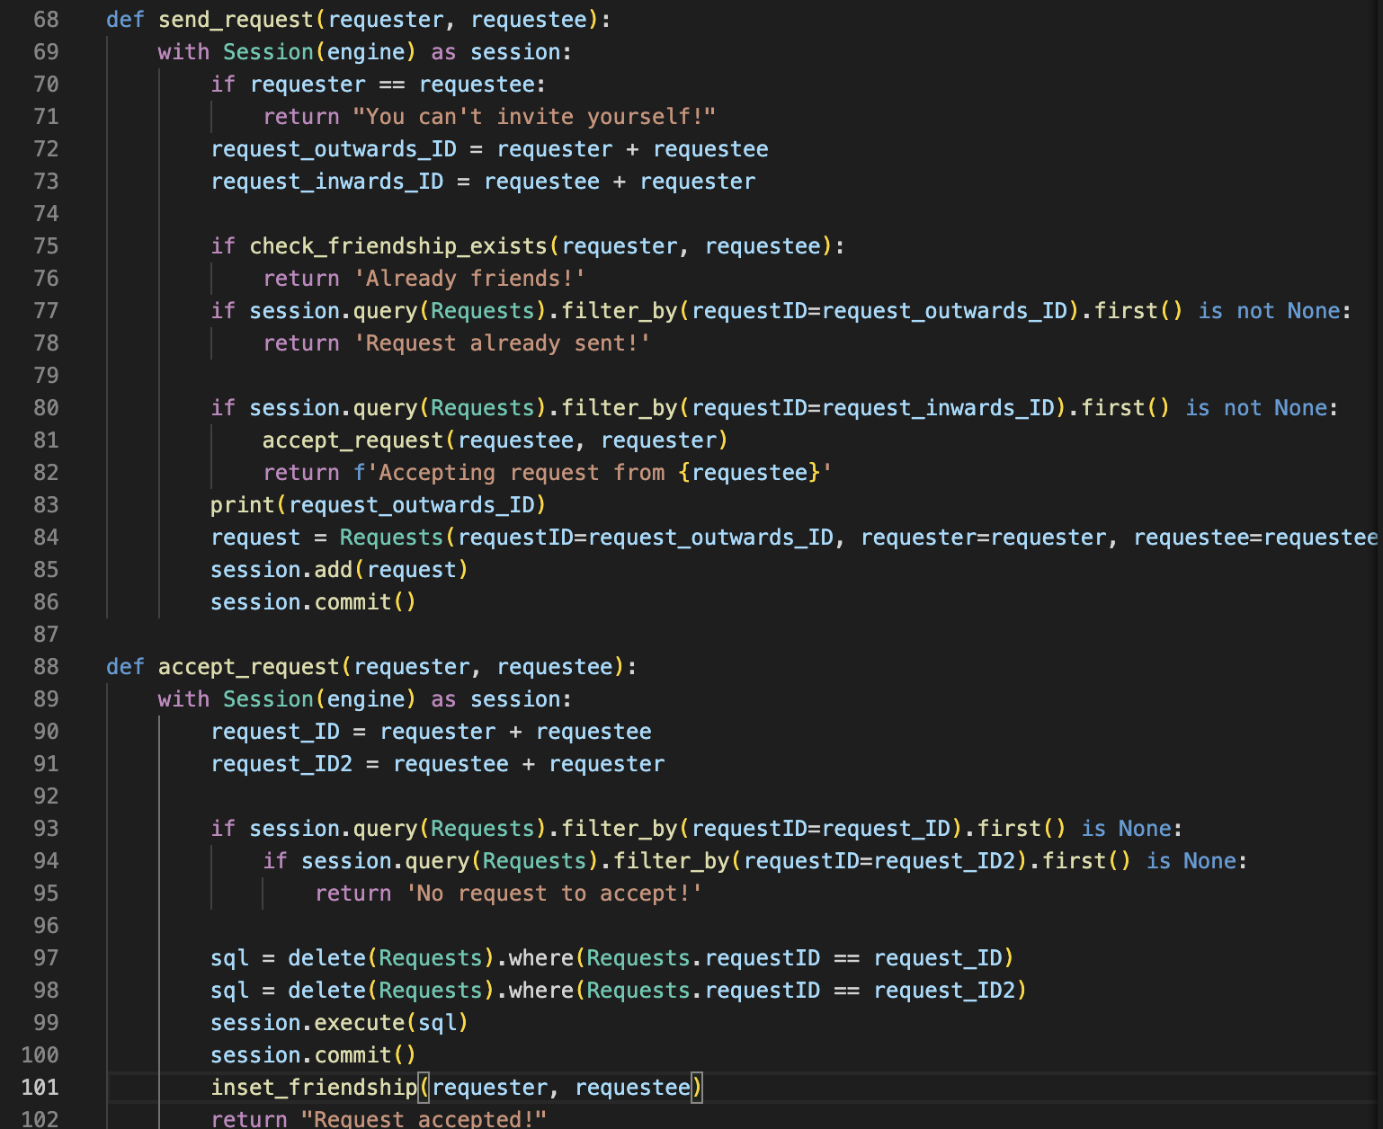

**Basic functionality requirement 3.**

